 **Project of Sound by 2102F**

**Submitted by:**

*Abdullah Khan*

**Lab-Automation**

**Faculty:**

*Sir Salih Sattar*

***TABLE OF CONTENTS***

* **Acknowledgement**
* **Table of Contents.**
* **Problem Definition.**
* **Customer Requirement Specification.**
* **Project Plan.**
* **E-R Diagrams.**
* **Algorithms.**
* **GUI Standards Document.**
* **Interface Design Document.**
* **Task Sheet.**
* **Project Review and Monitoring Report.**
* **Unit Testing Check List.**
* **Final Check List.**

***PREFACE***

**First of all, I would like to thank ALLAH the almighty, who gave us mind to think and heart to feel creatively. Creation depends on thinking.**

**Many people contributed to this project, and I would like to thank all of them. I guess I should start with my Teacher *Sir.Salih Sattar* of APTECH for his expert advice.**

**Very special thanks to all our teachers who gave us valuable teaching and brilliant suggestion and always encourage us to do the best. Indeed class fellows are very important and we would like to thank all of them for their kind appreciation, encouragement and moral support.**

**I would also like to express our deepest gratitude to our parents whose well wishes enabled us to transform our dream into a reality. Finally my sincere thanks to my Teacher Mr Salih Sattar for all their assistance in making this concept a reality.**

***ER-Diagram:***

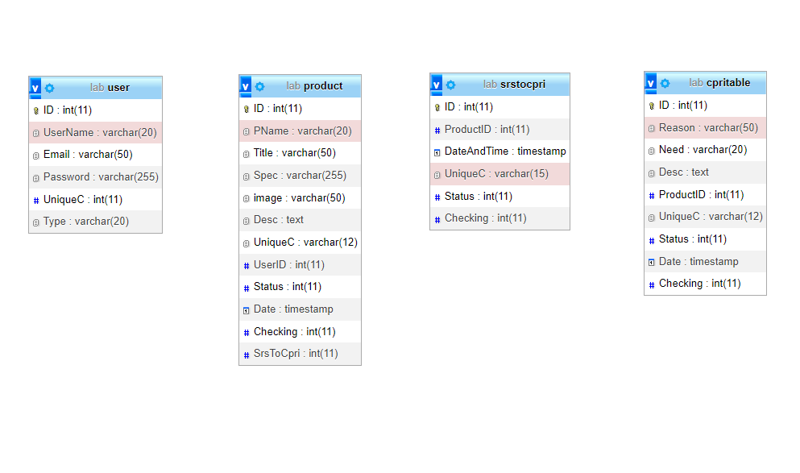

***ACKNOWLEDGEMENT***

**I am thankful to almighty, ALLAH with his grace and mercy I have been successful. I am hereby presenting project *‘lab-Automation’* in your hands. I have tried my best to take all relevant and important topics in consideration so that this project may become more effective.**

**This is ADSE Third SEMESTER project. I have tried our best & struggled for a better out look to come. This project has been developed with the help of ‘PHP’. This assignment was to make for “***electrical products like switch gears, fuses, capacitors, resistors***,** *etc***” as a project and I have used ‘Visual Studio Code” for programming.**

***PROJECT SYNOPSIS***

This is to certify that symphony

Lab-Automation website has been completed with its all functionality by the students of **2102F**

*Abdullah Khan*

Project of

Appliances

**Introduction:**

**The SRS Electrical appliances are the manufacturers of some electrical products like switch gears, fuses, capacitors, resistors, etc…. These products after manufactured they are sent for testing where the product is subjected to some testing conditions, and then after the testing is successful at their laboratories they are sent to CPRI for further testing process, so that they can get it approved from CPRI and then release the product into the market. If the testing fails then the product is sent back for re-manufacturing it and then they are again subjected to tests.**

**Customer Requirements:**

**Initially after the product is manufactured the companies testing department tests the product and maintains the details of the testing done like the type of testing and as well the result of the testing that the product is subjected to. Actually the testing process usually depends on the type of the product to be tested.**

**Actually the testing records are maintained in papers and they mark how many products are sent for testing and as well how many are tested successfully and as well how any are not. Actually each product that is manufactured is allocated with some product id (10 digit code which includes the product code, the revise of the product, and the manufacturing number) and the records of testing are maintained based on the product id so that it becomes easier to track which product is tested successfully and which has failed the testing, and what all are needed to be done to over come the defaults, so that the products that are failed when subjected to tests can be sent for re-making.**

**It has become a tedious job as there is no automation in the process and as well it is a time consuming process for maintaining the records of testing and filing it, as it has to be shown to the concerned department, as based on the results of testing they decide whether to send the product for further testing process or for re-making the product.**

**Some times misplacing of the records or the products take place or it might even happen like the record of one product is entered for the other, etc….. as in the testing department itself there are various departments which are based on the type of testing, and a product need two or more types of testing. As soon as a testing is finished in one department it is to be sent to the other department that performs the other type of testing.**

Functional Requirements:

* **The details are needed to be captured based on the type of the testing and as well based on the product.**
* **The status of the testing and as well the detailed remarks is also needed to be captured.**
* **An advanced search option is needed to be included so that one can fetch the details of the testing at an ease.**

***SCREENSHOTS:***

**1: Screen Shots of WebSite :**

S.S 1: Showing login page

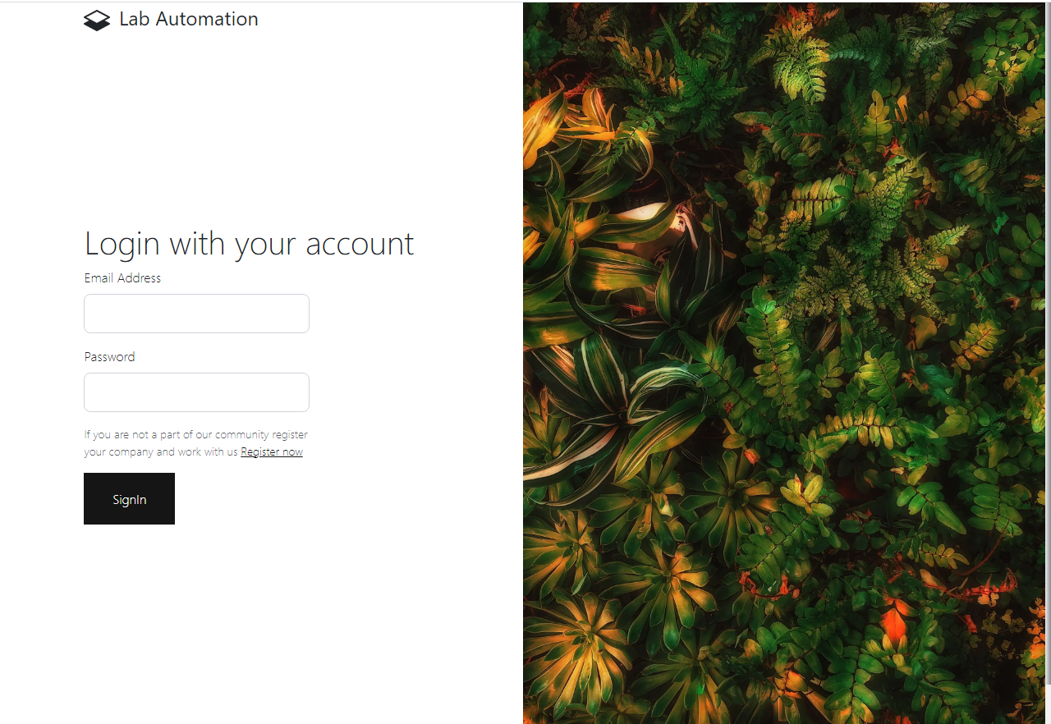

S.S 2: Showing REGISTER PAGE.

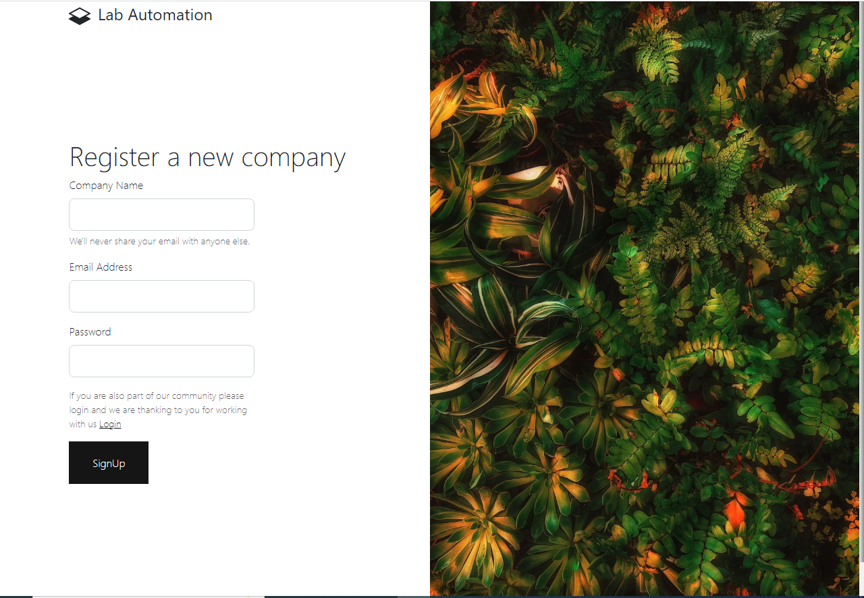

S.S 3: Form to See User in main page

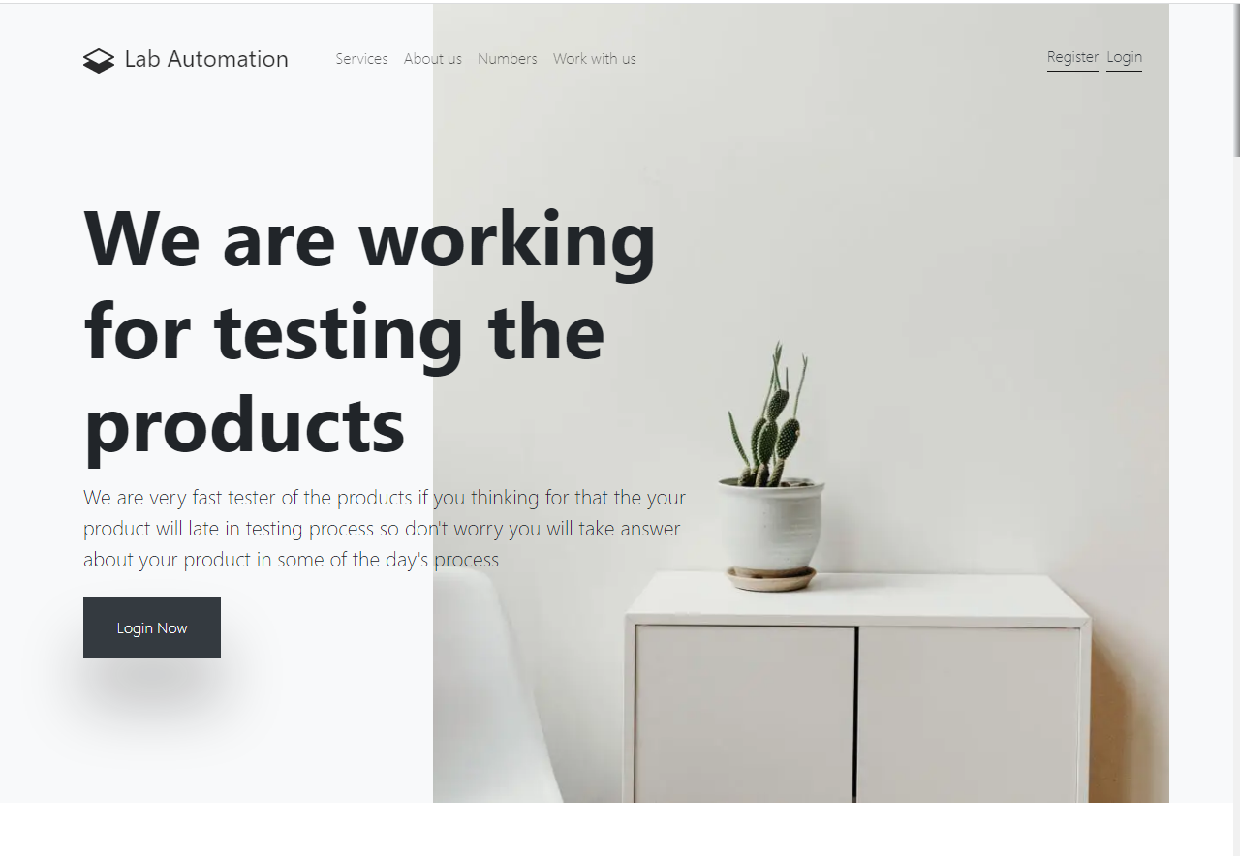

S.S 4: USER WELCOME PAGE

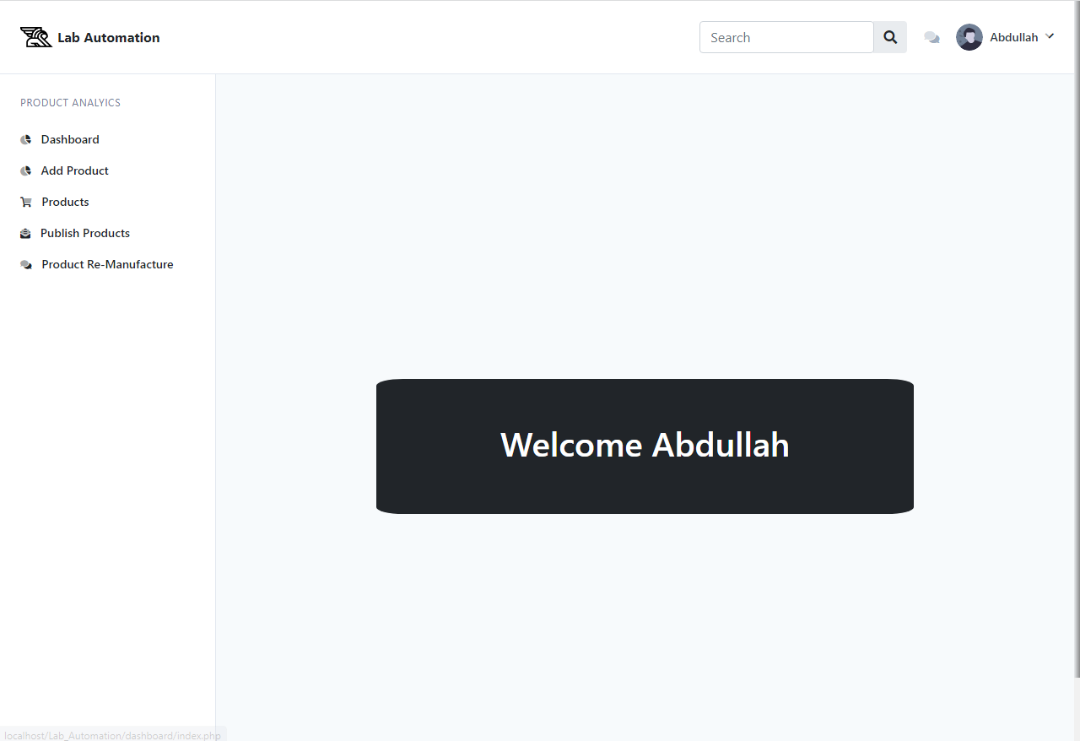

S.S5: USER Add product

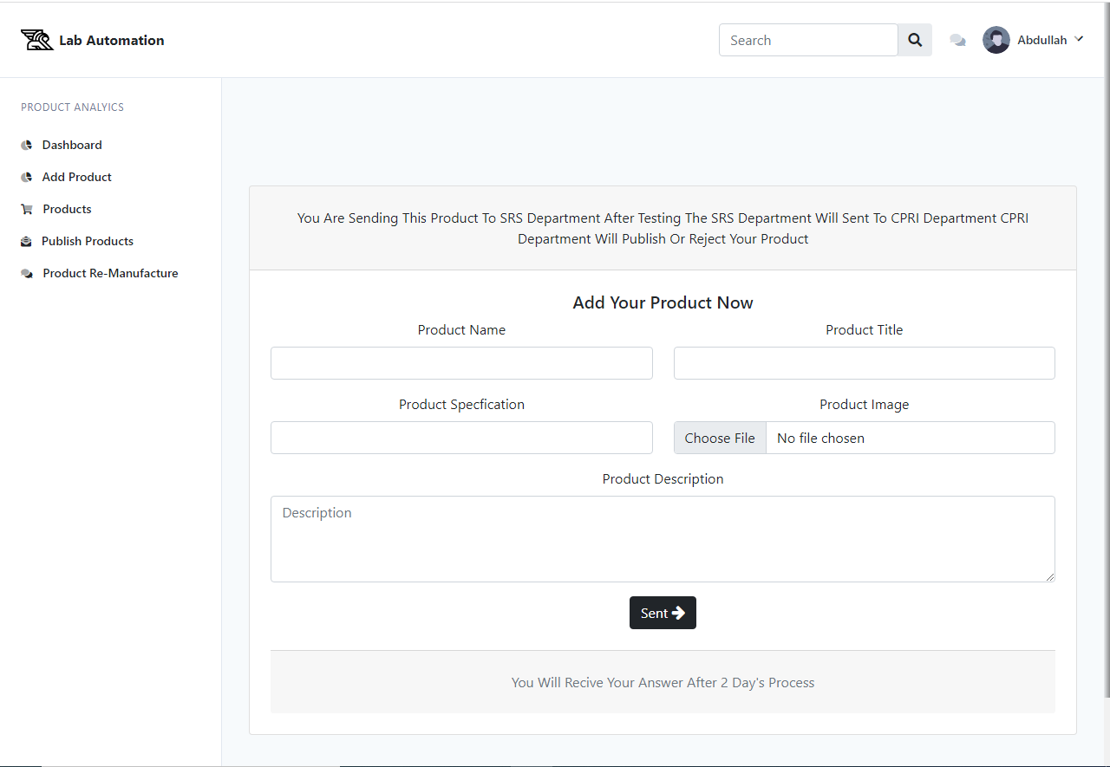

S.S 6: user Product process

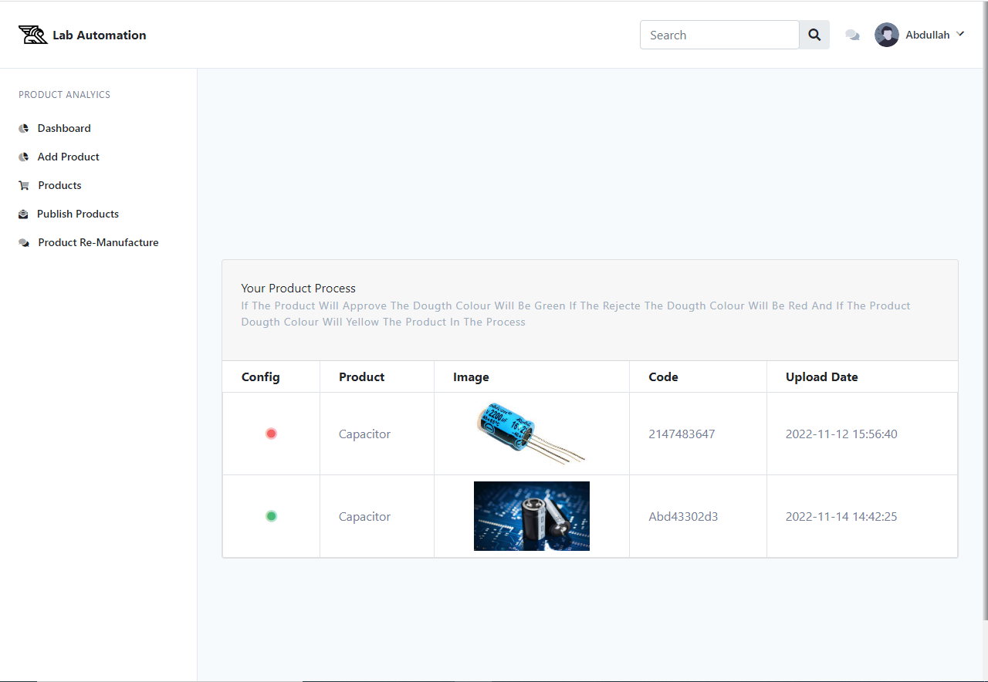

S.S 7: user search Product

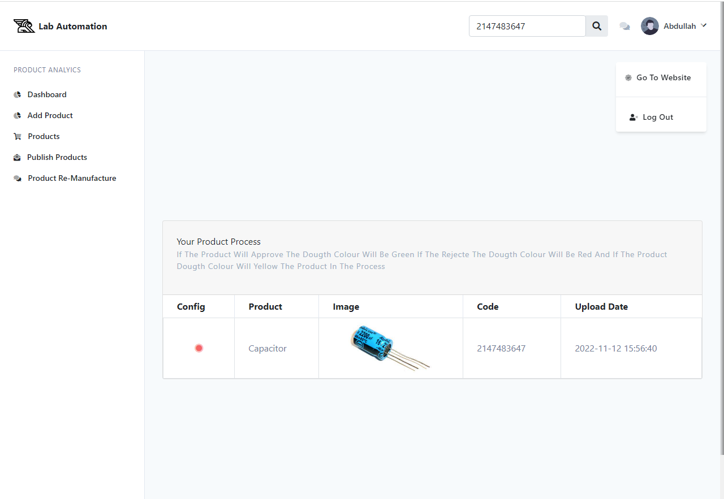

S.S 8: user Product publish

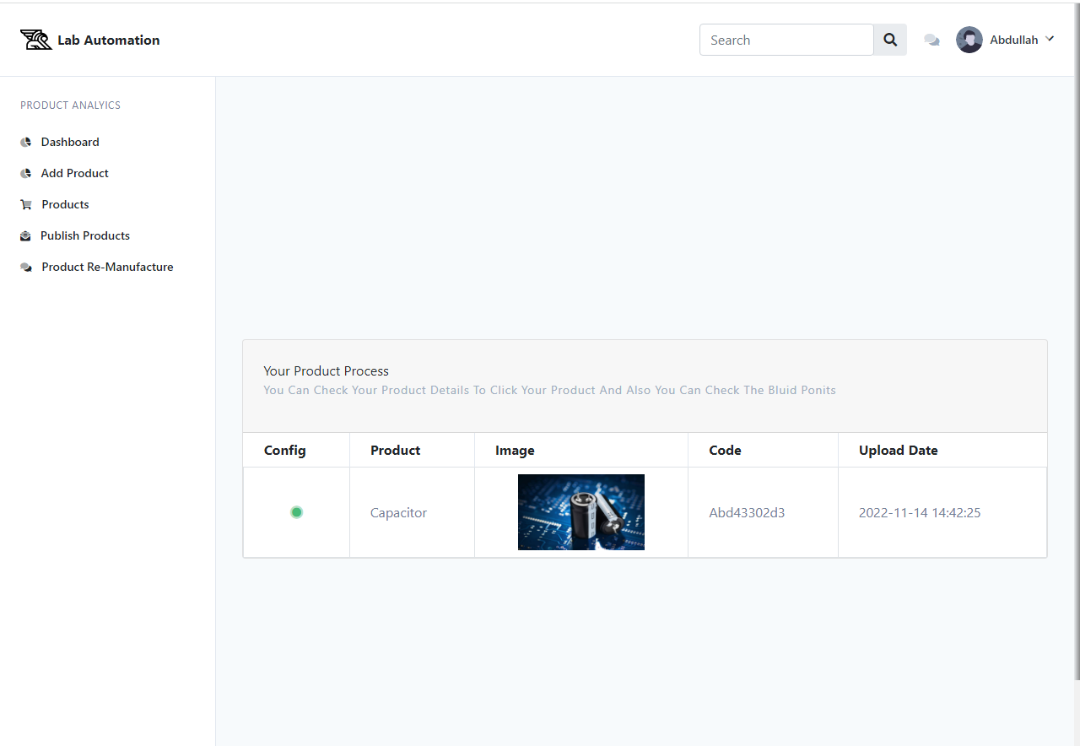

S.S 9: user search publish reason

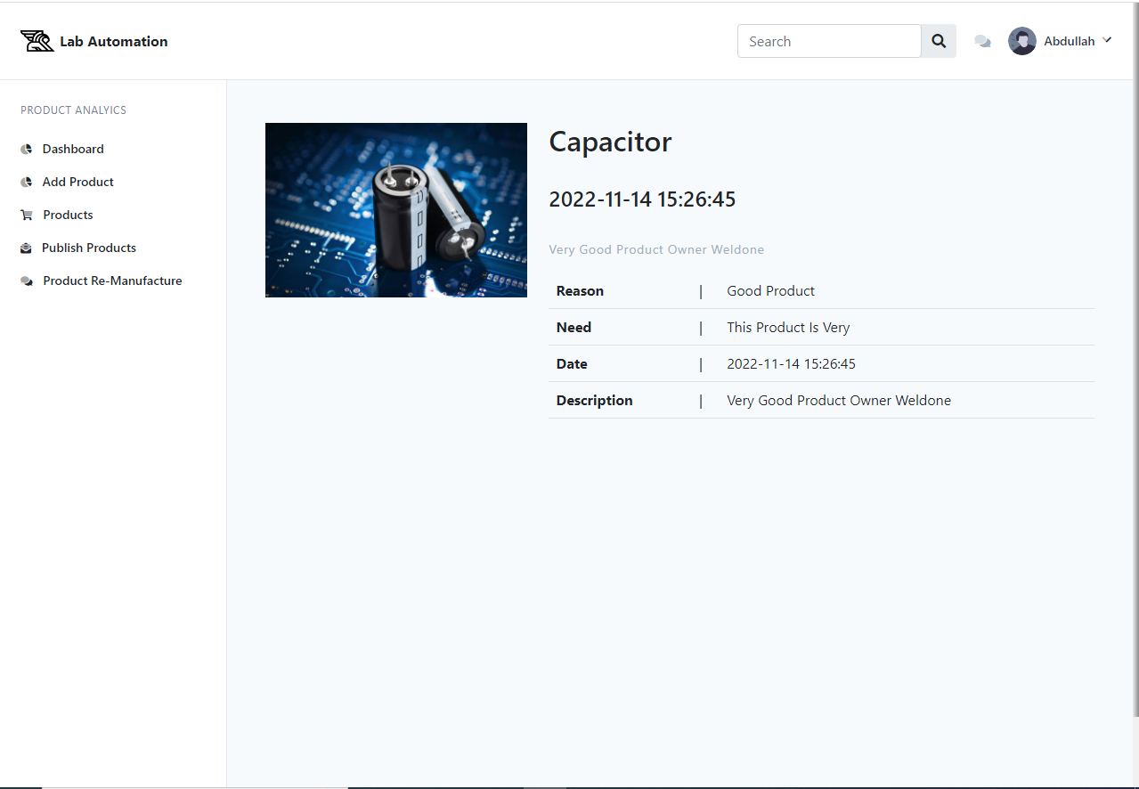

S.S 10: user rejected product

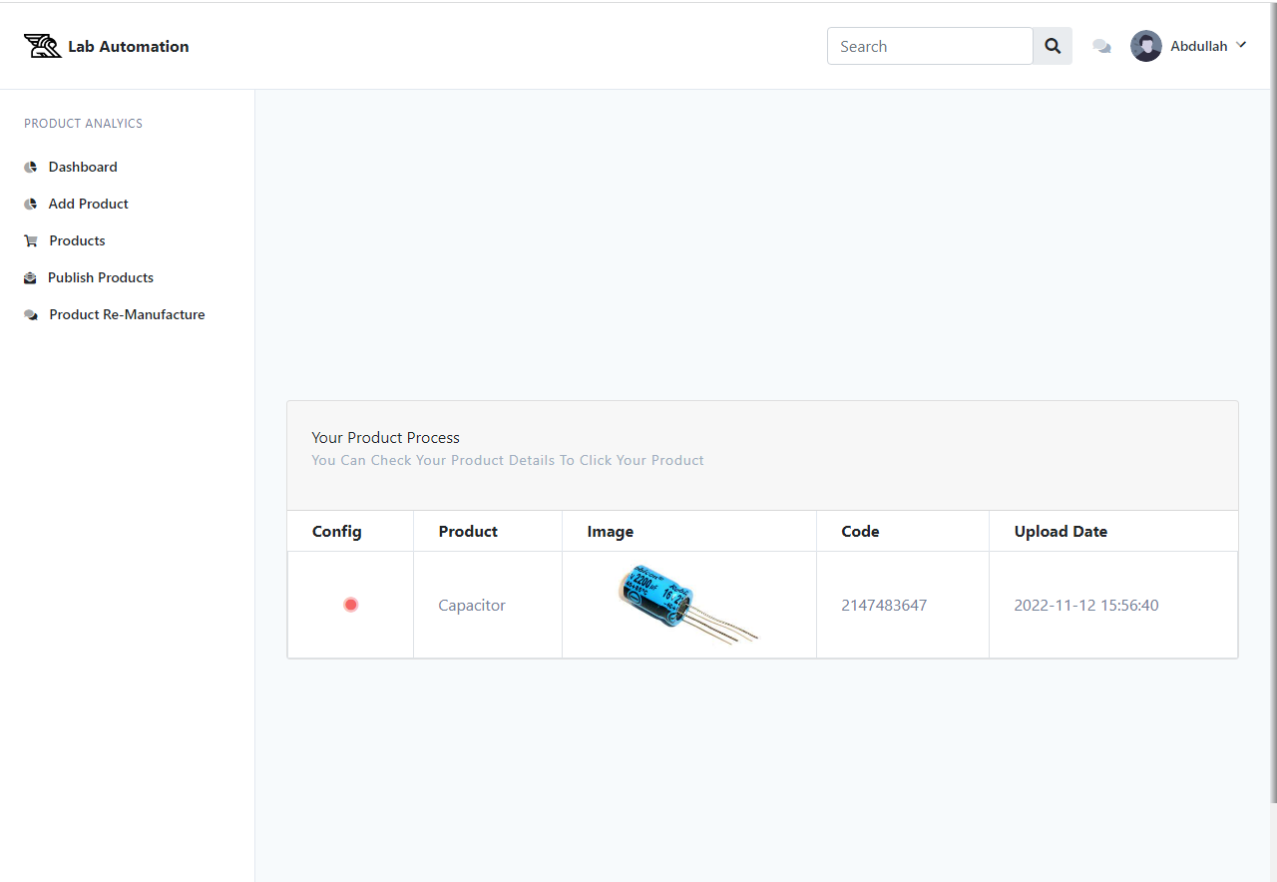

S.S 11: user reject product reason

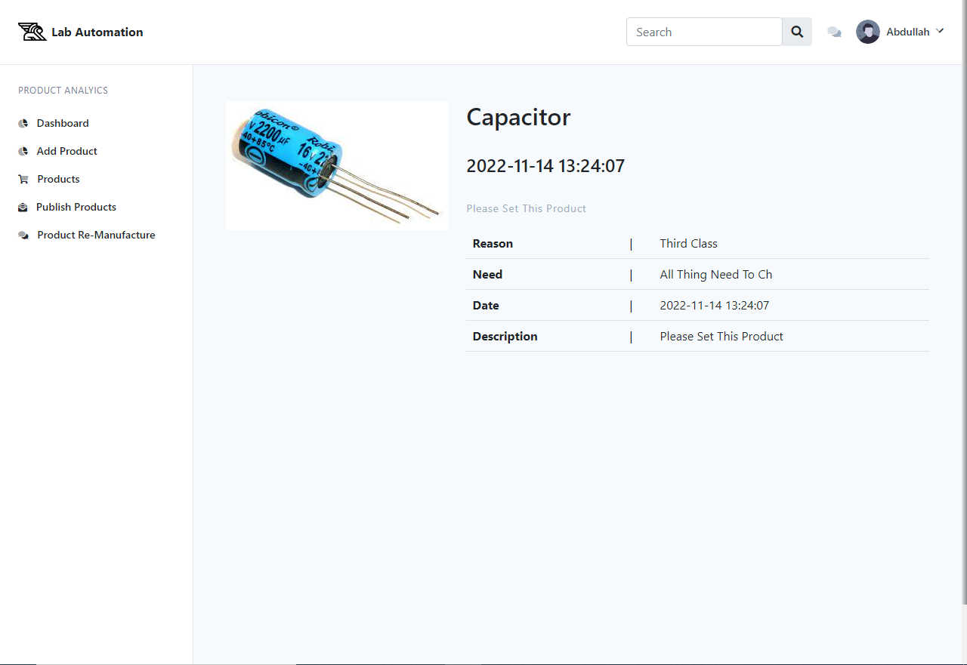

**2: Screen shots of srs department**

S.S 1: srs welcome page

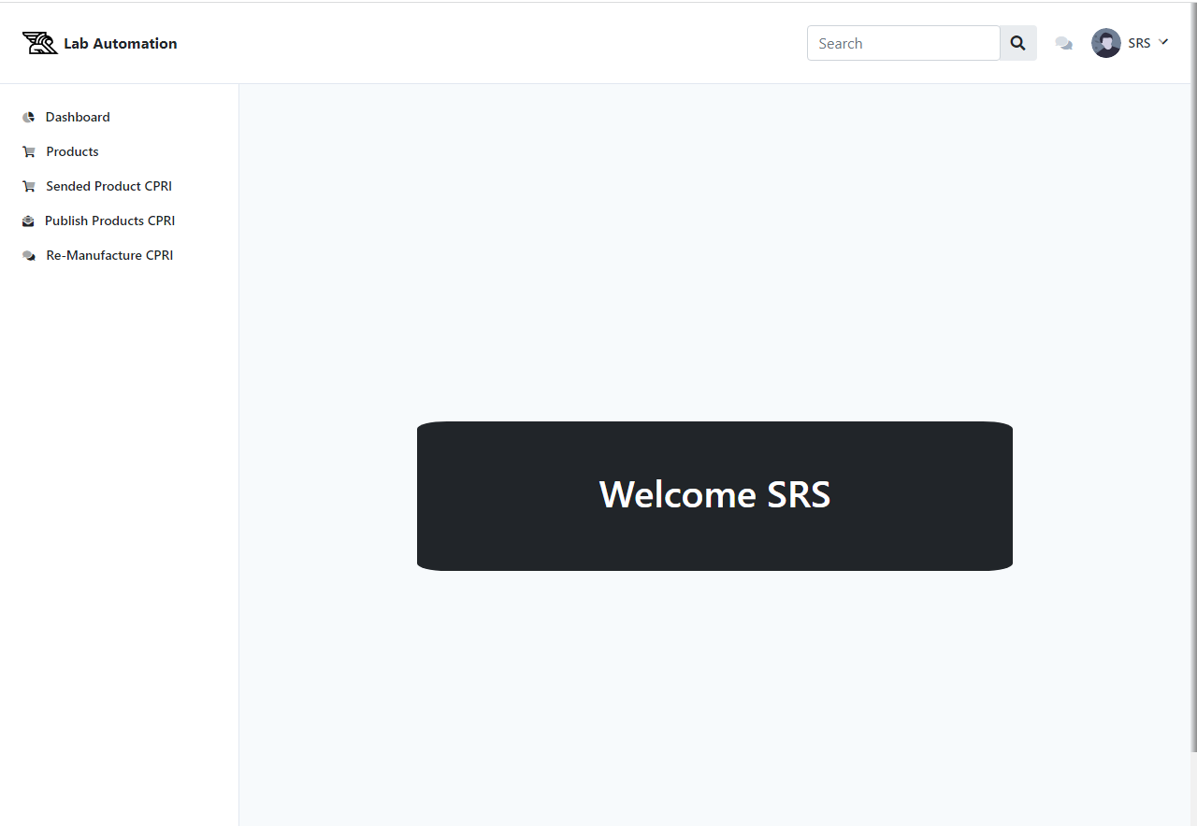

S.S 2: srs products page

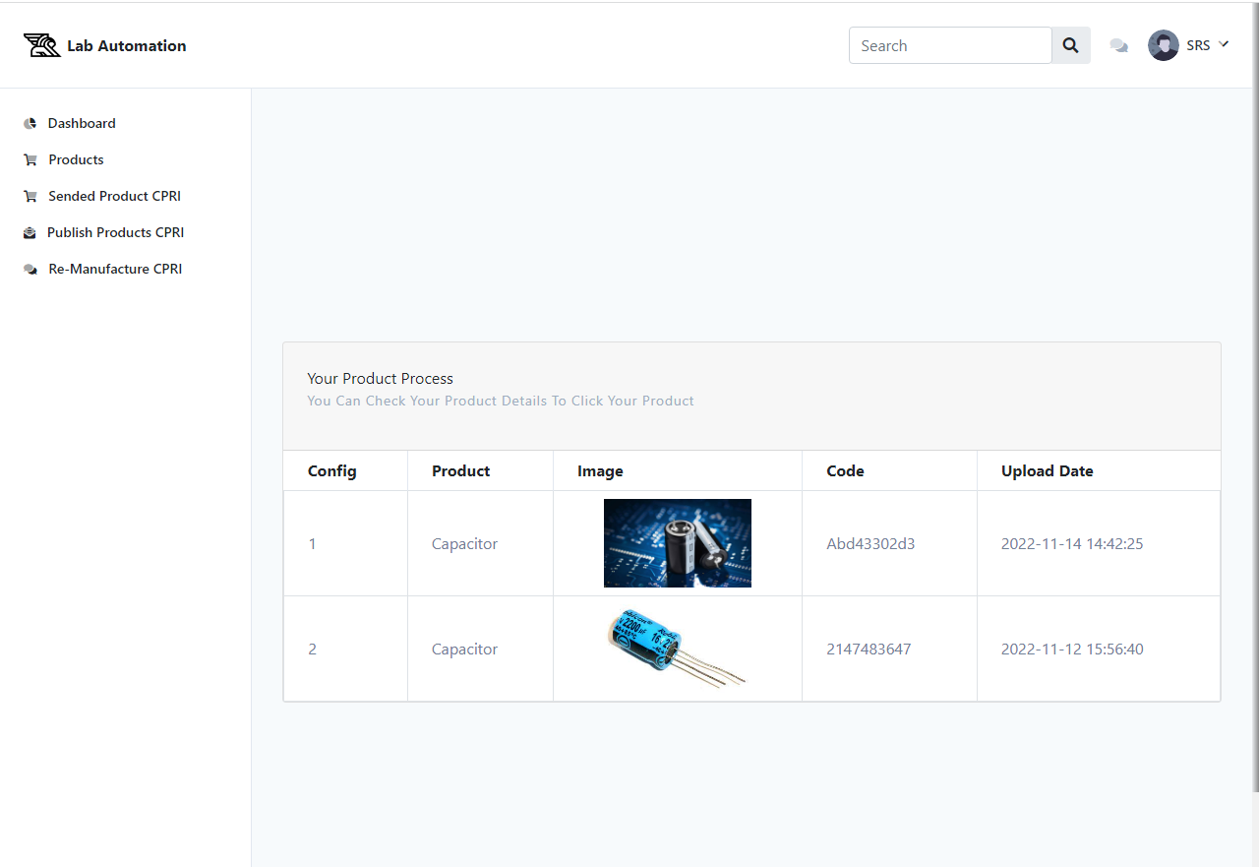

S.S 3: srs search products page

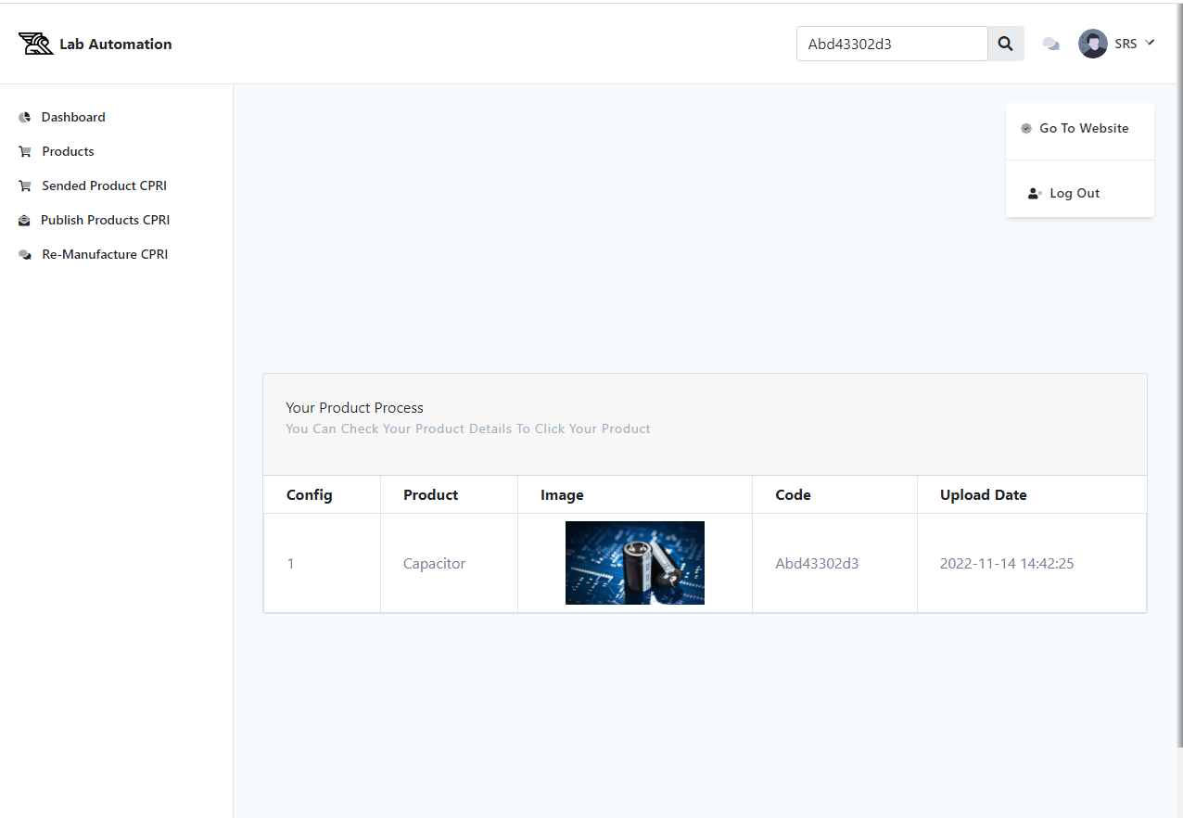

S.S 4: srs showing new product

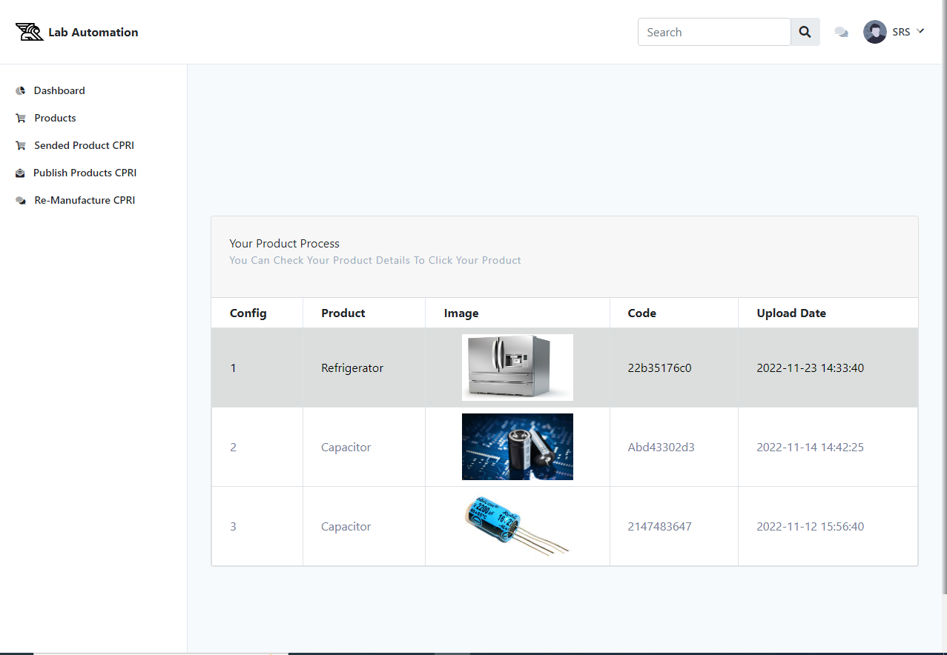

S.S 5: srs product detail page and send to cpri Department

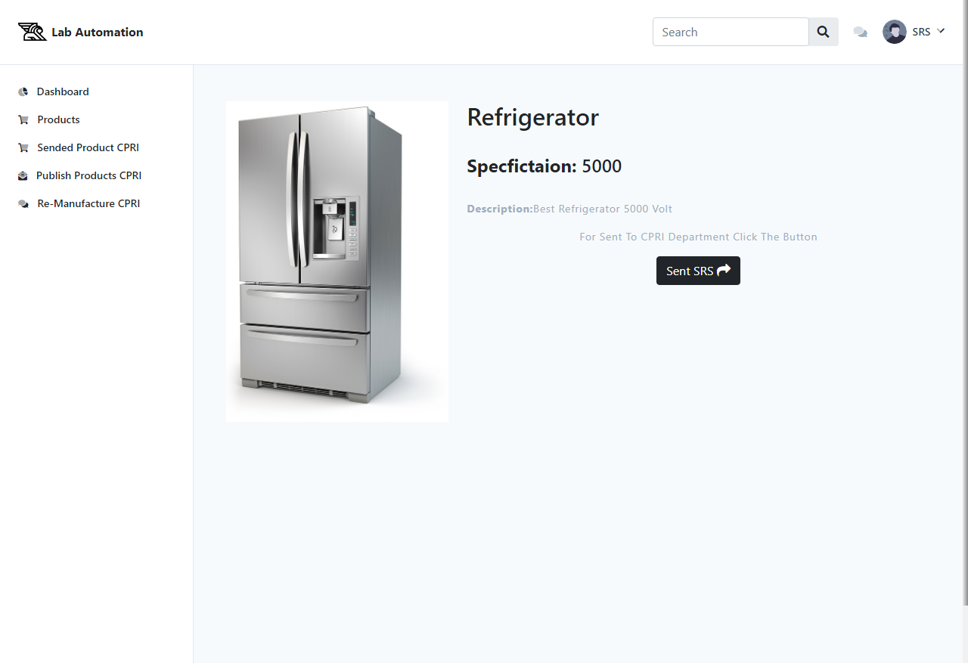

S.S 6: srs side publish product from cpri side

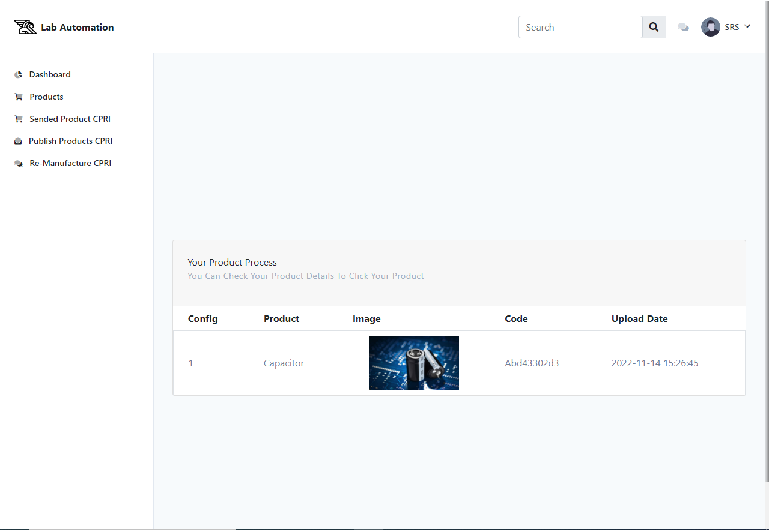

S.S 7: srs side publish reason product from cpri side

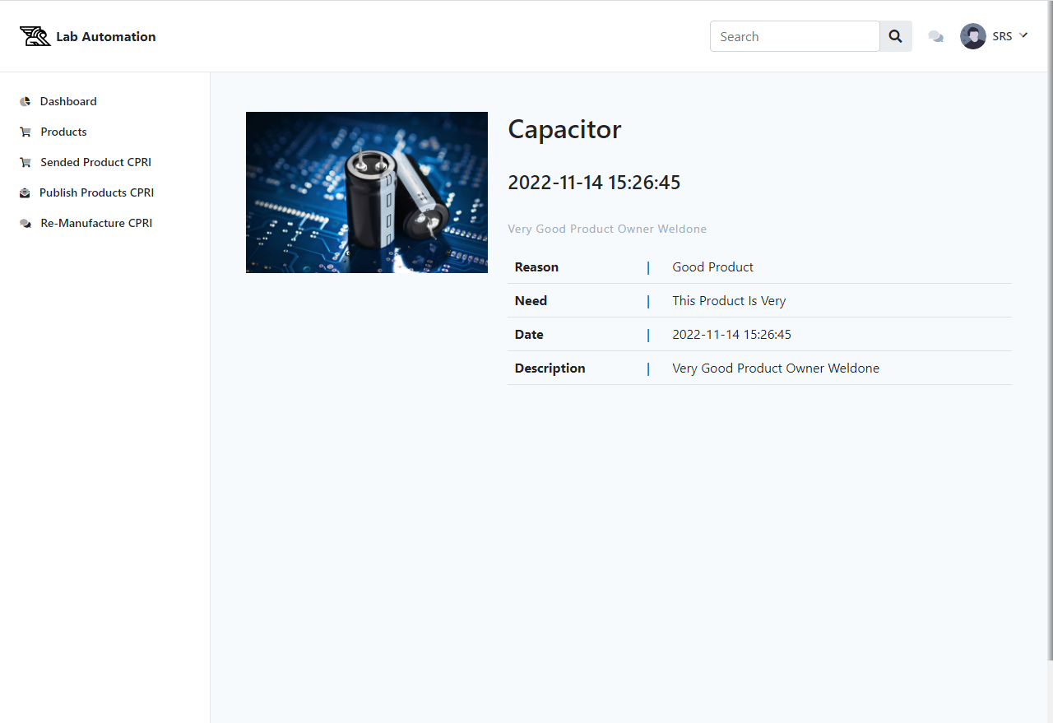

S.S 8: srs side rejected product from cpri side

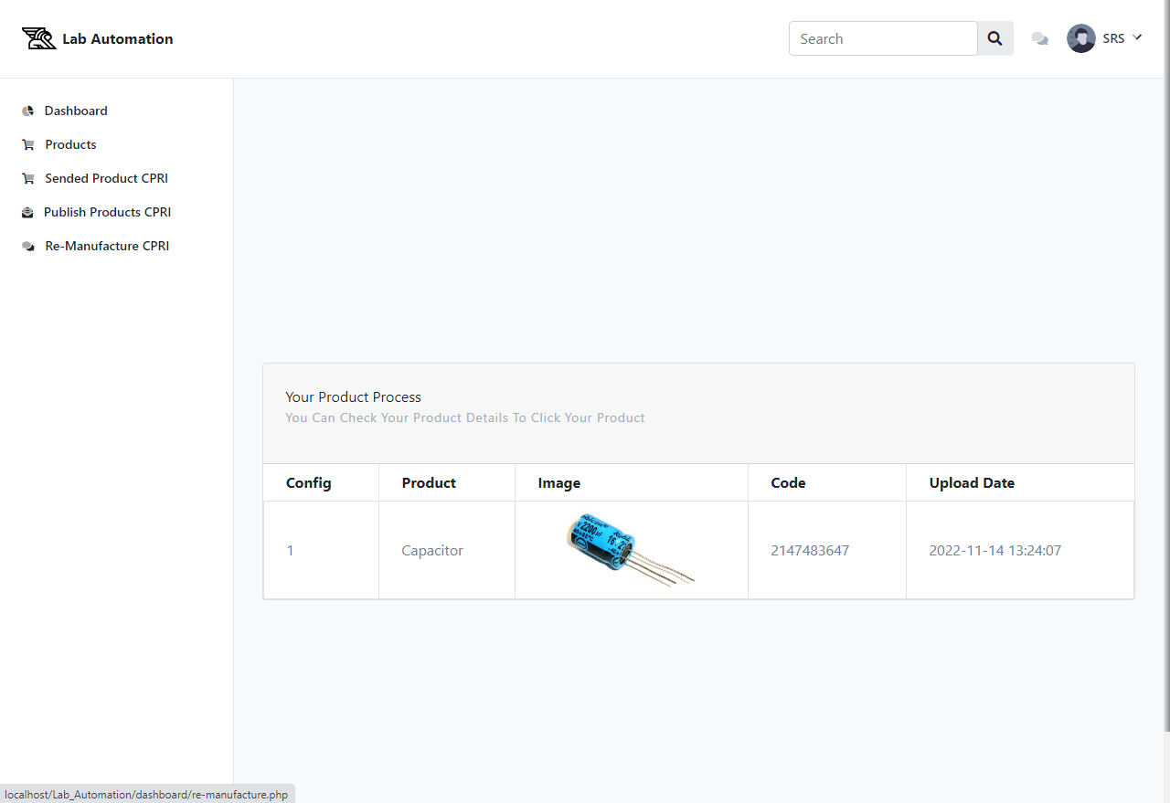

S.S 9: srs side reject product from cpri side

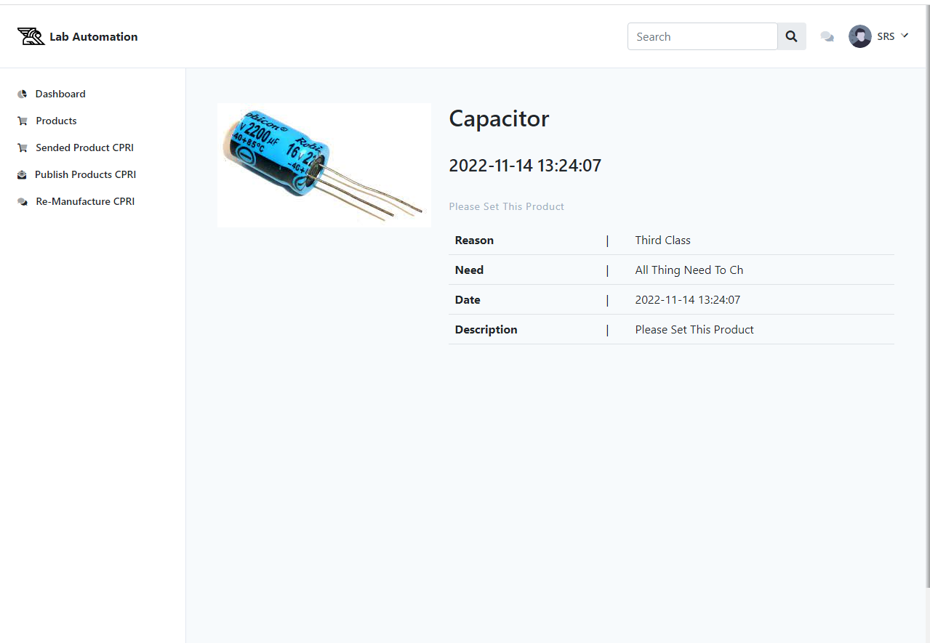

**3: Screen shots of cpri department**

S.S 1: cpri welcome page

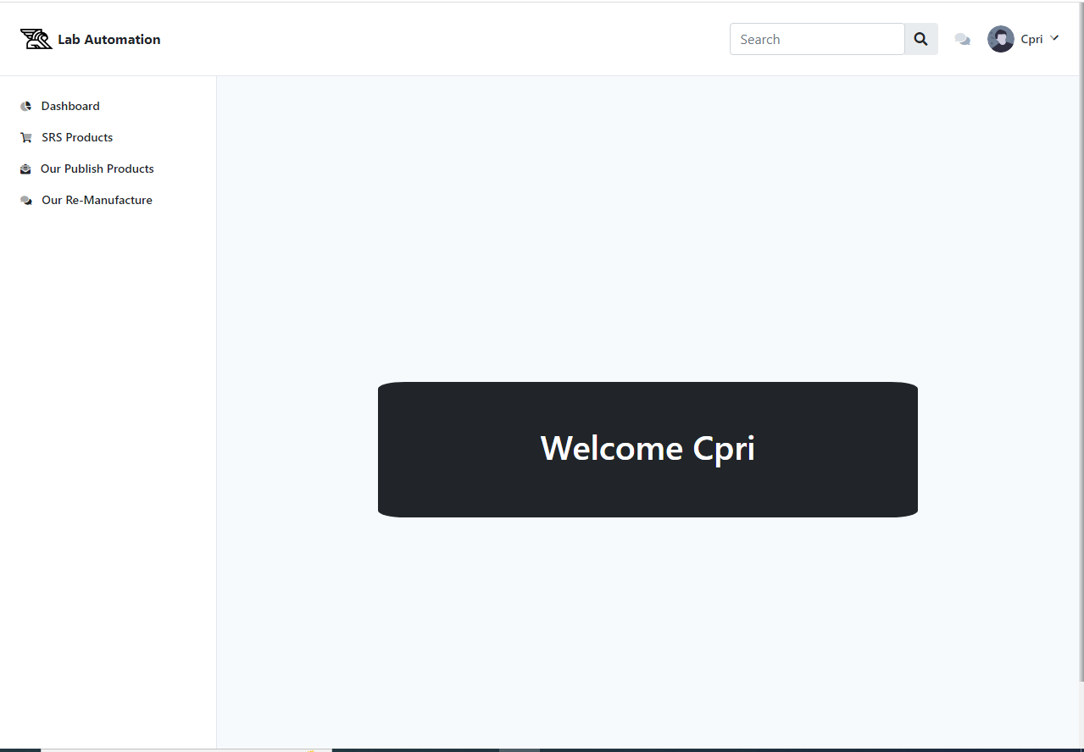

S.S 2: cpri products page

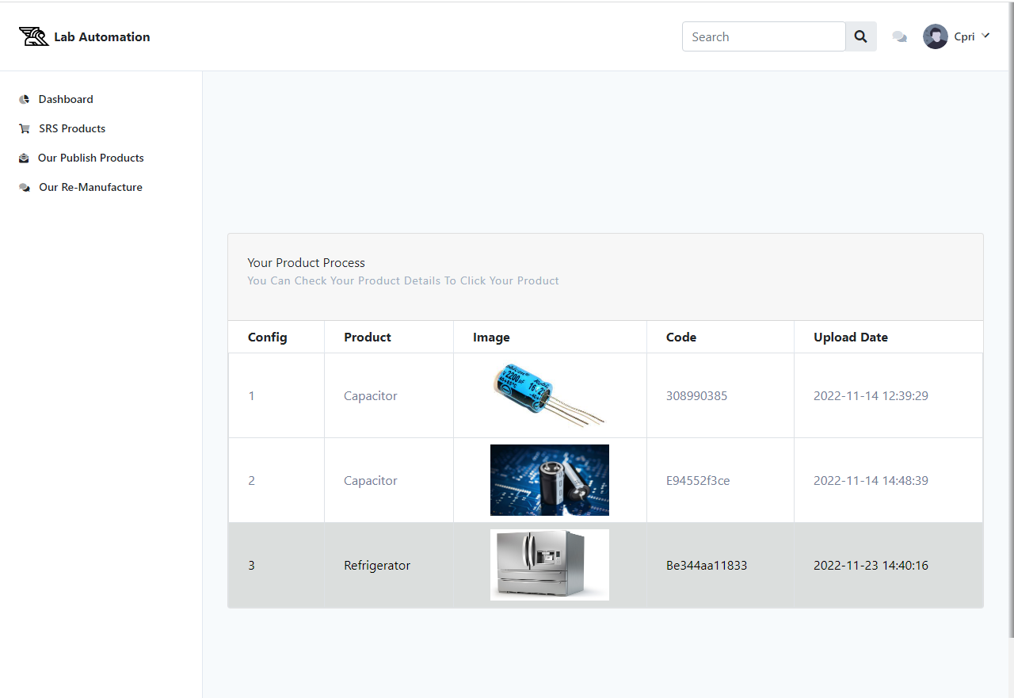

S.S 3: cpri product detail

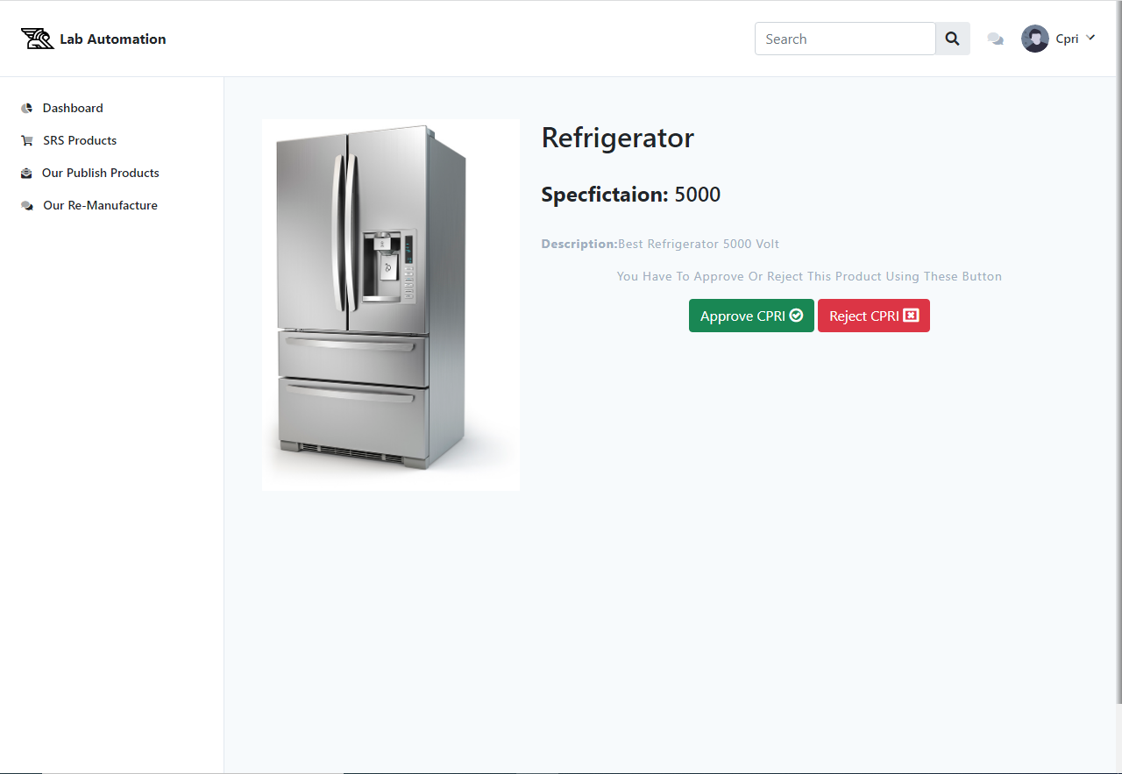

S.S 4: cpri publishisg product

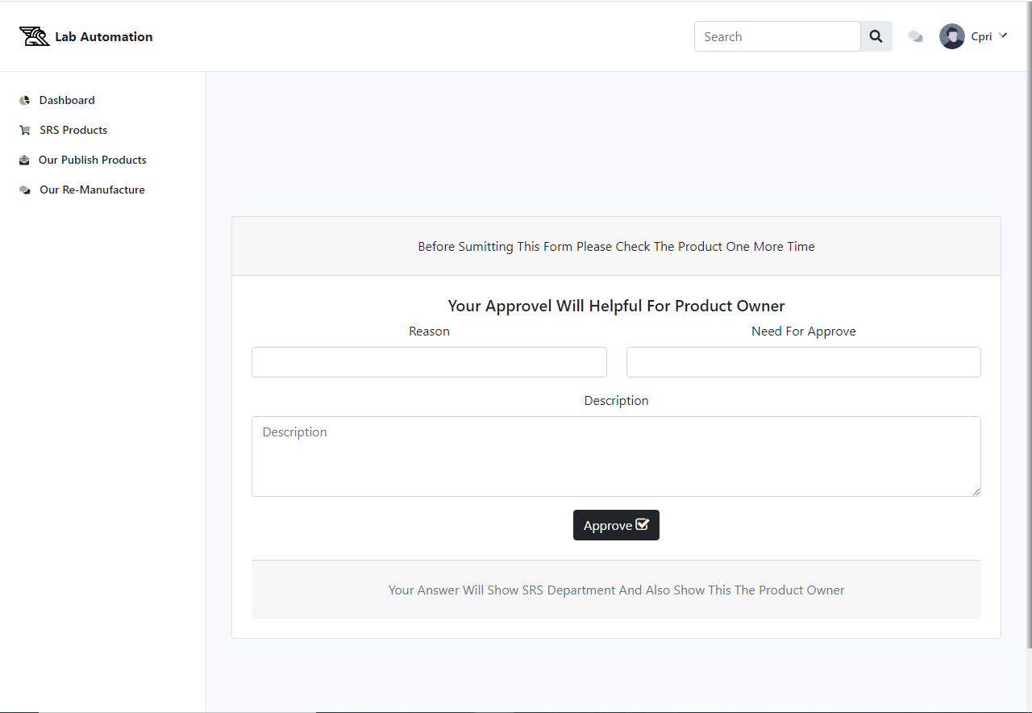

S.S 5: cpri rejecting product

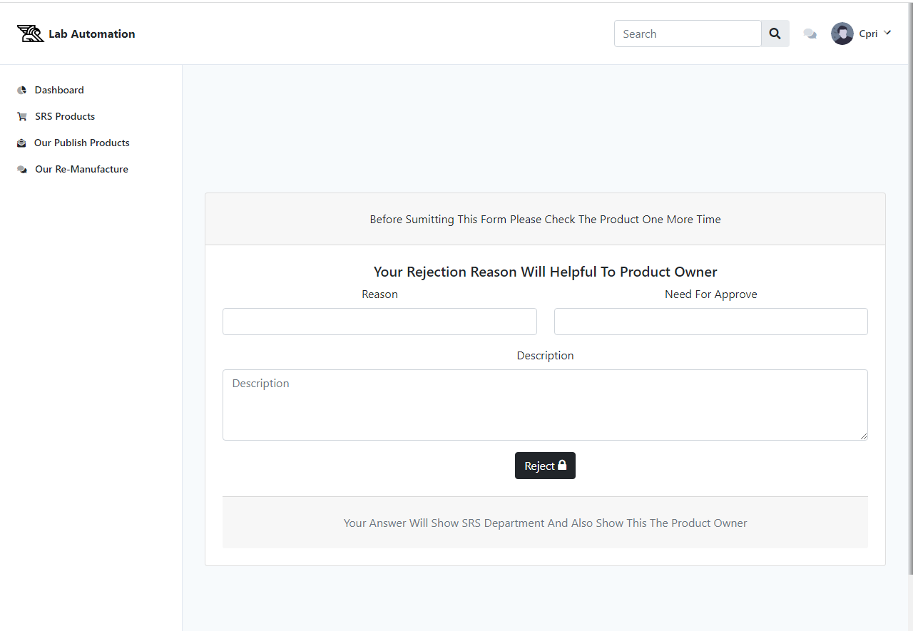

S.S 6: cpri publish products

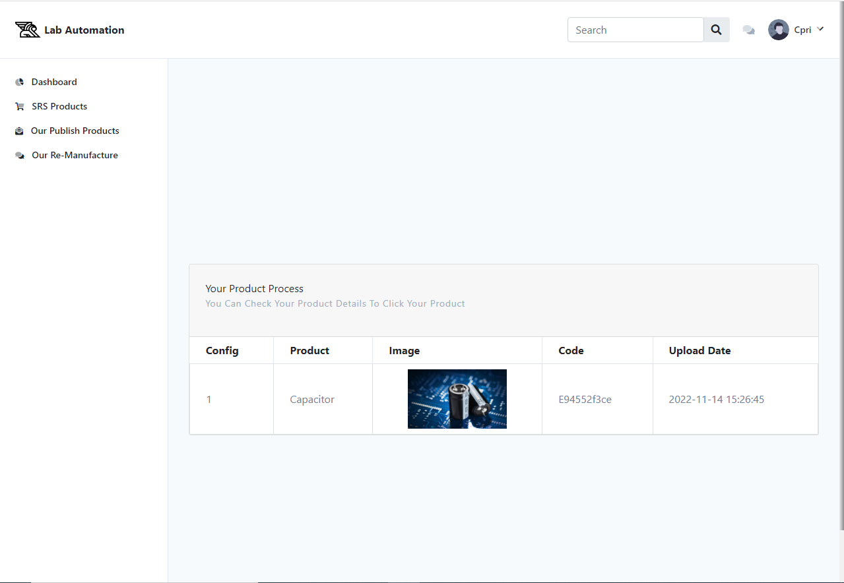

S.S 7: cpri rejected products

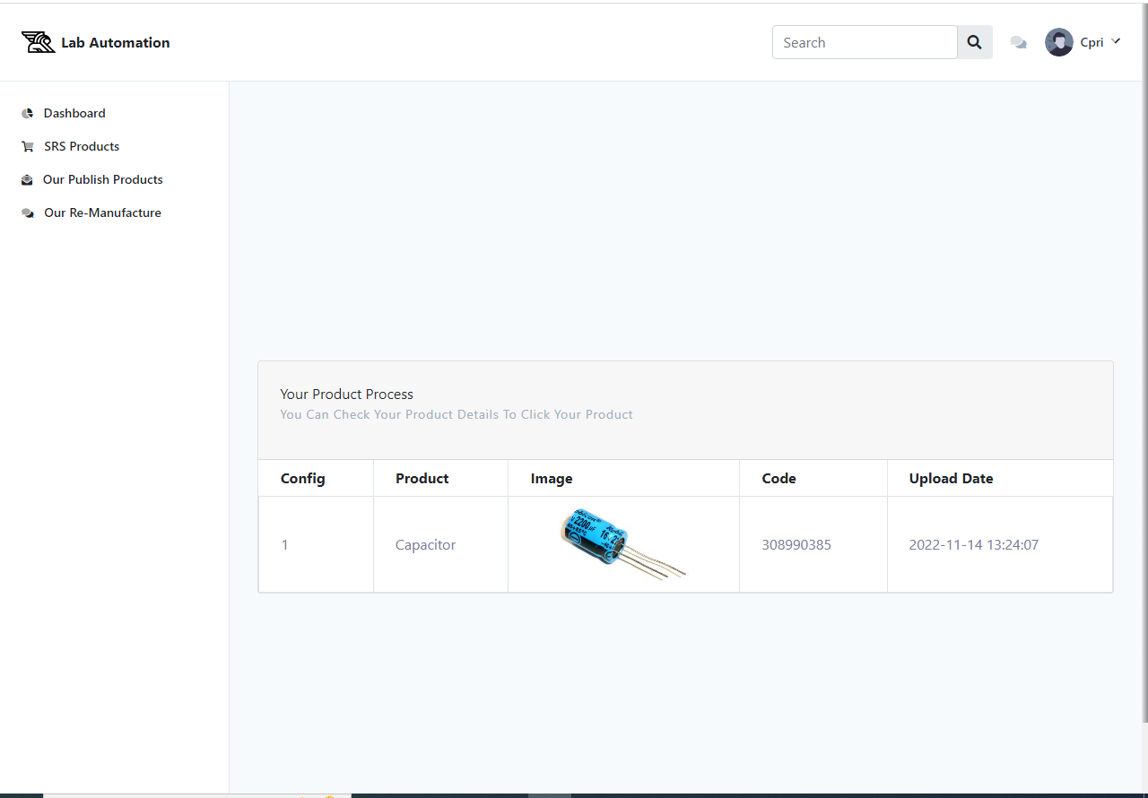

S.S 7: cpri search products

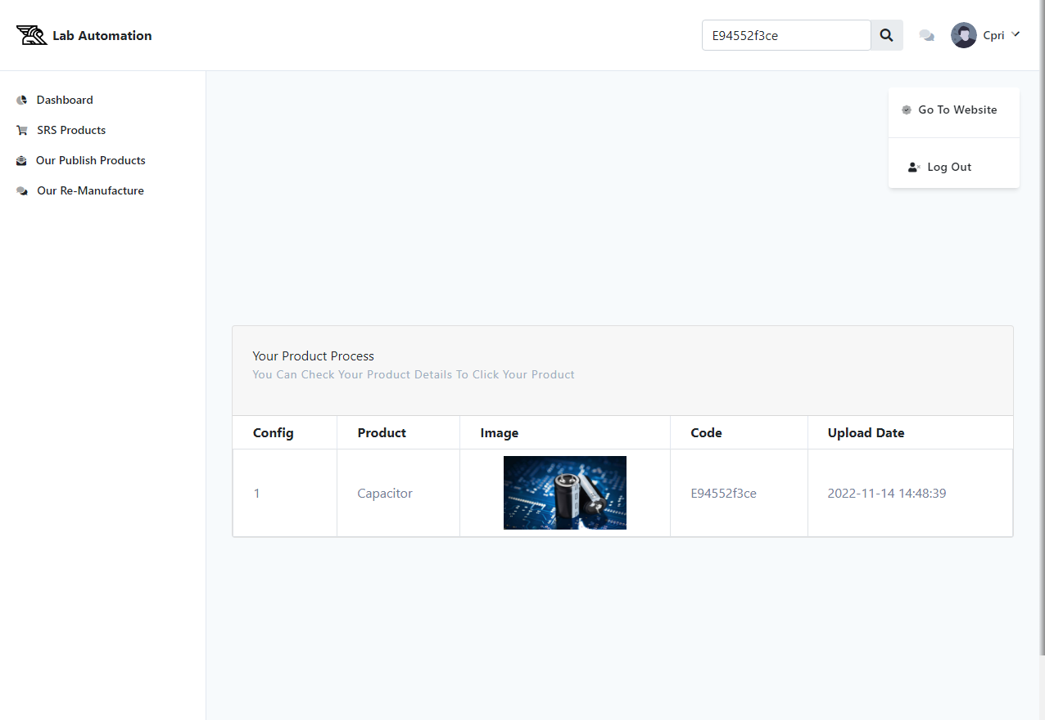

Code screen shots:

S.S 1: Login code

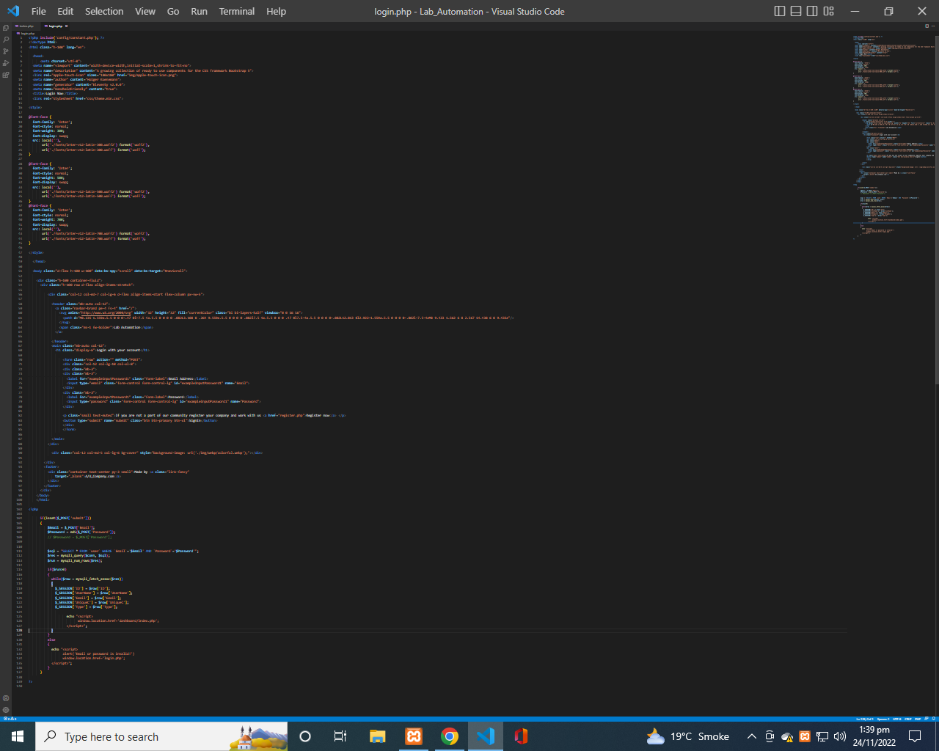

S.S 2: register code

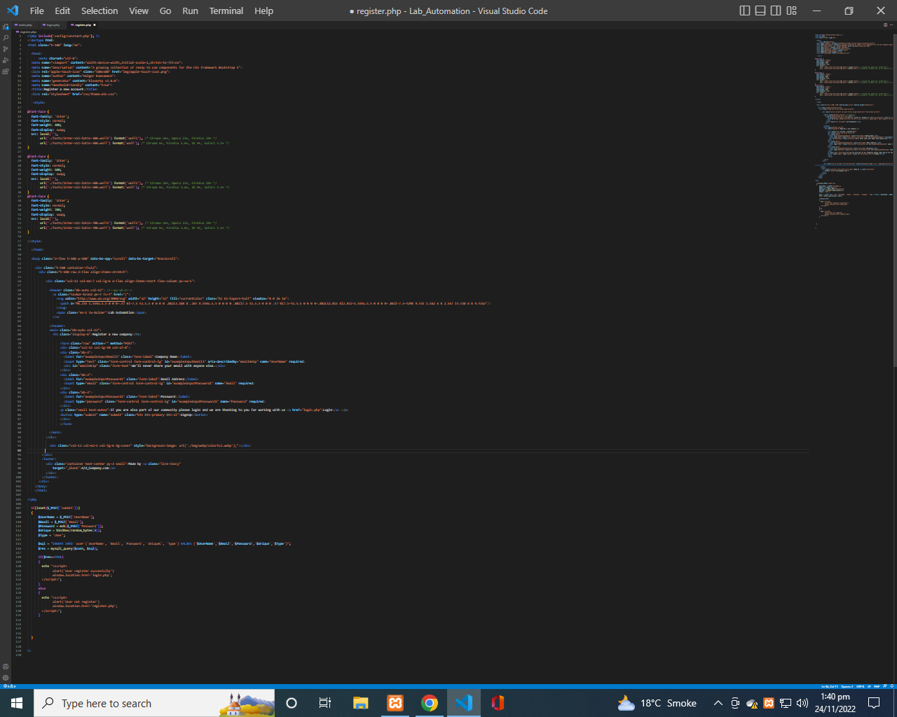

S.S 3: Index page ss1

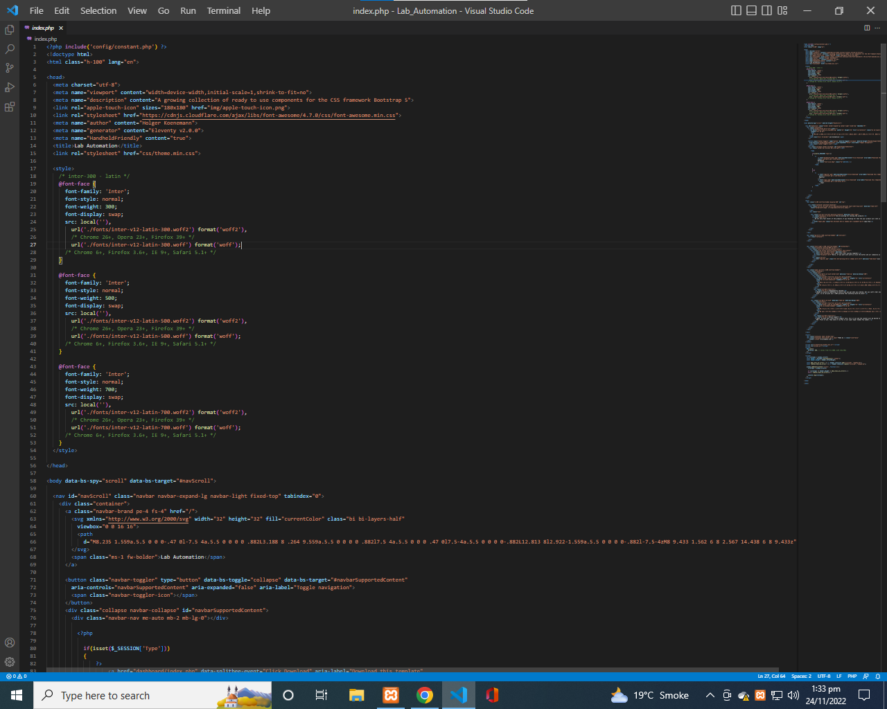

S.S 4: Index page ss2

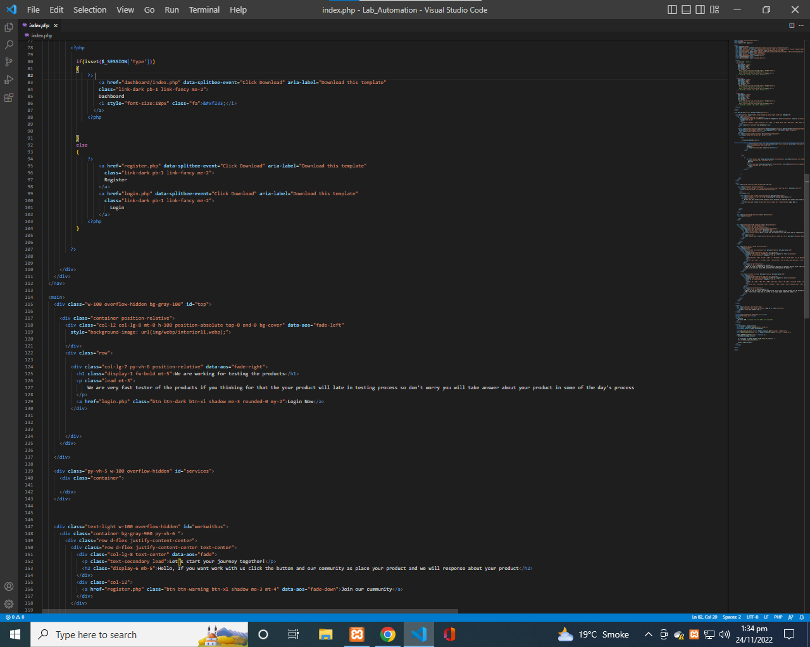

S.S 5: Index page ss3

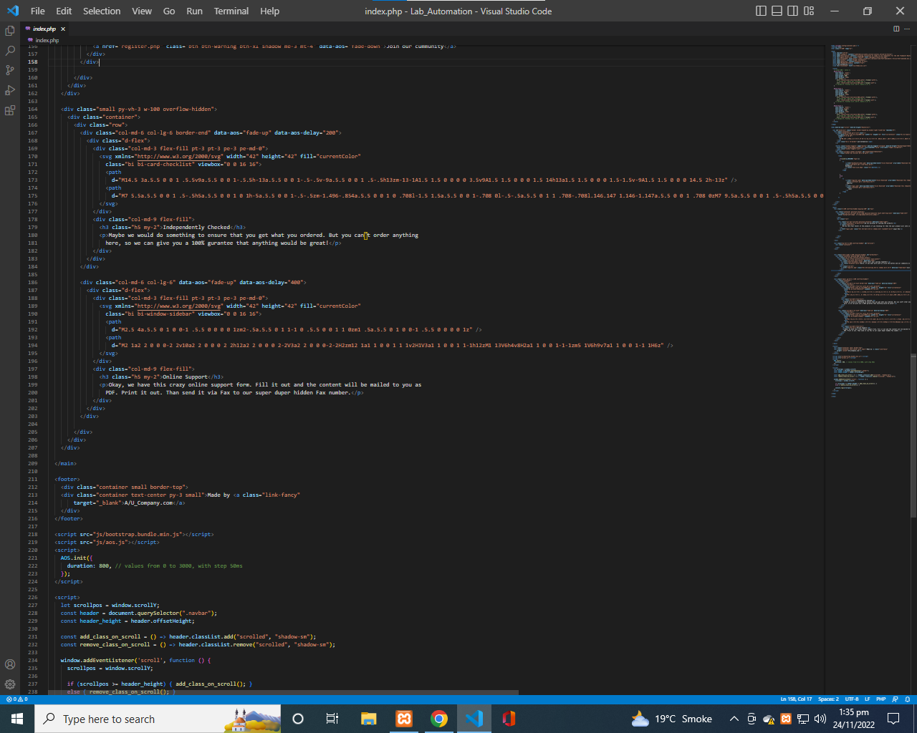

S.S 6: Index page ss4

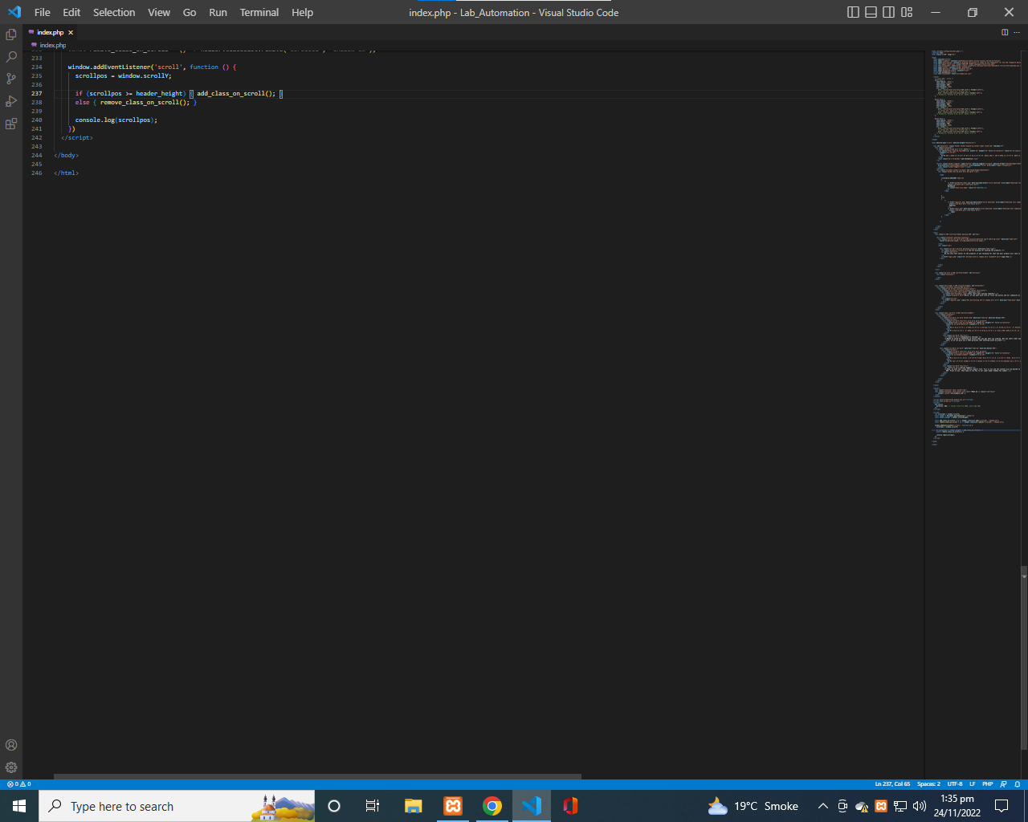

S.S 7: Database connection code

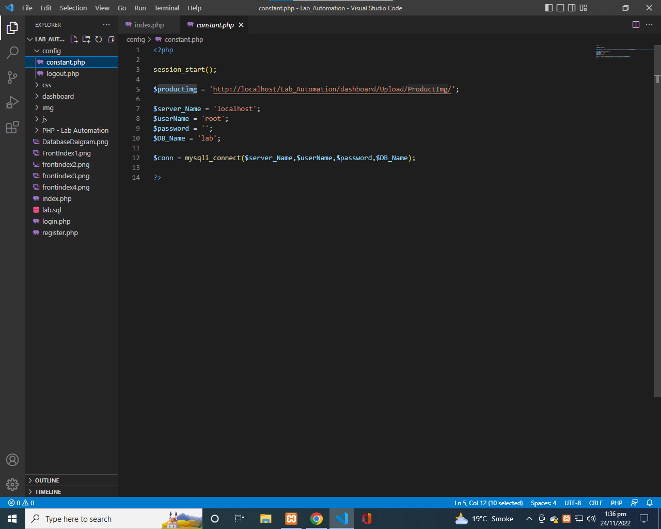

S.S 8: dashboard header code ss1

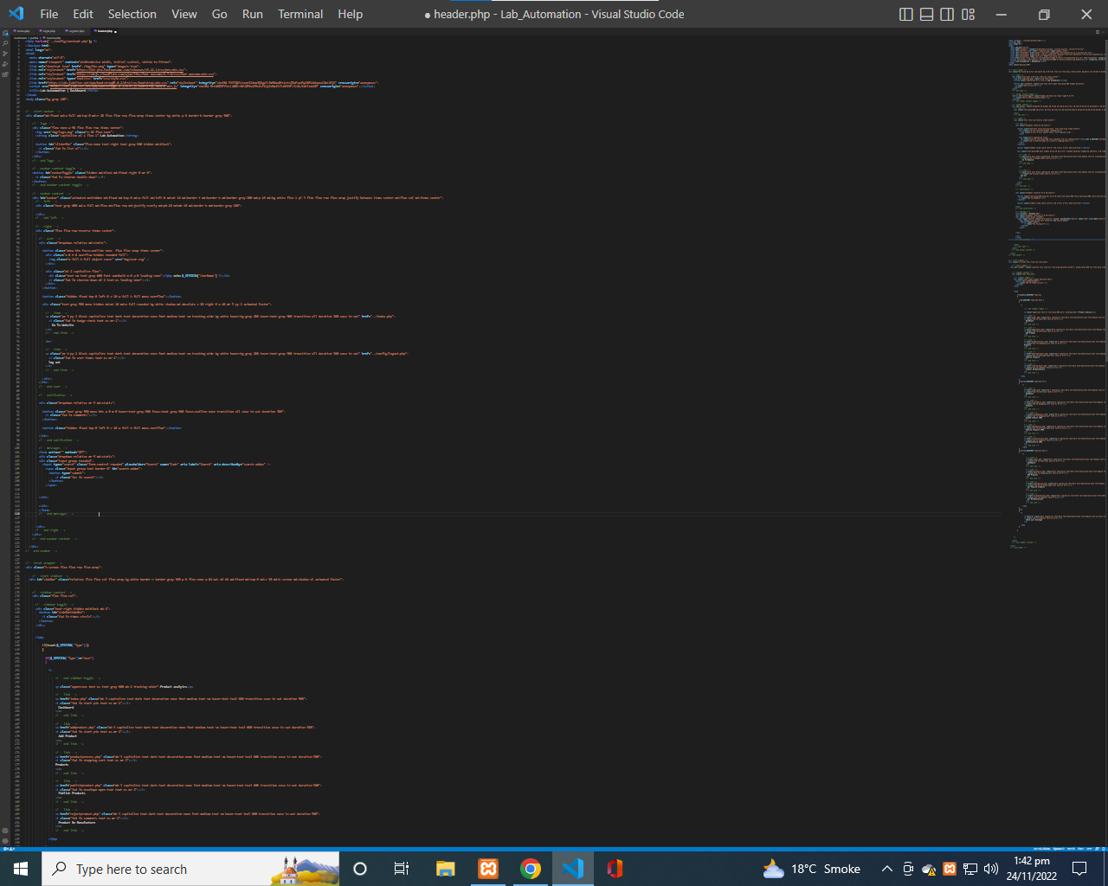

S.S 9: dashboard header code ss2

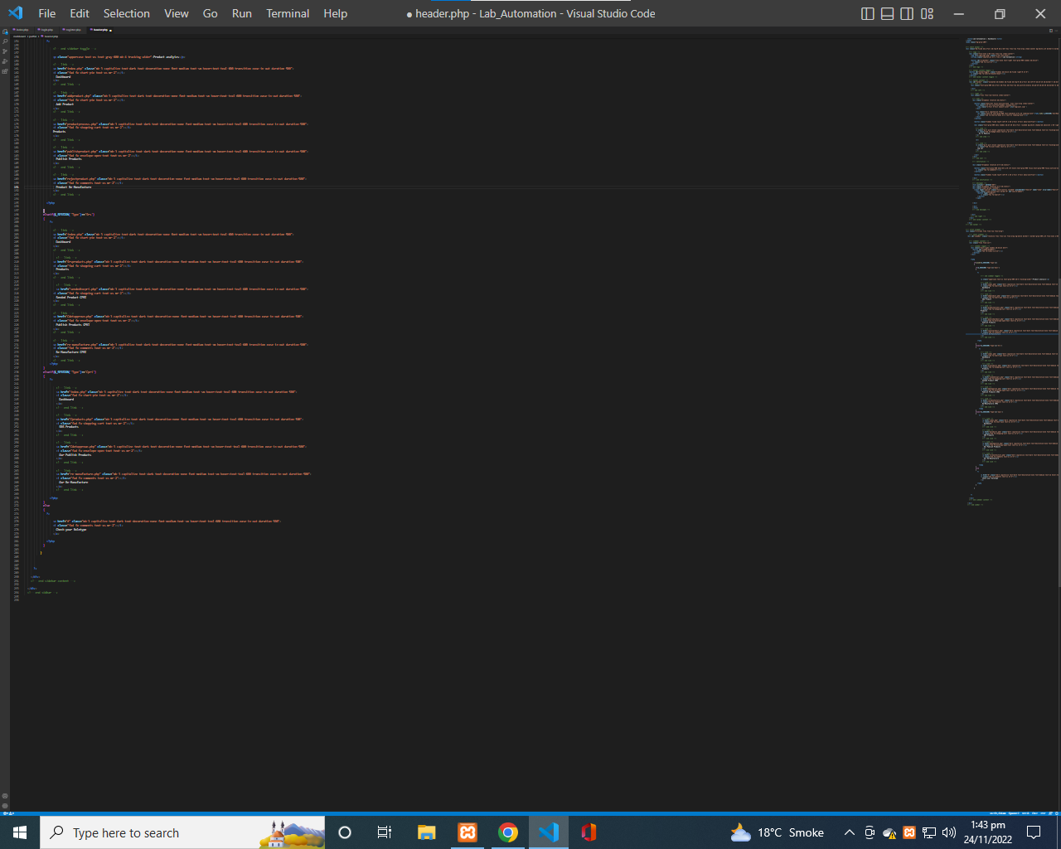

S.S 9: dashboard footer code

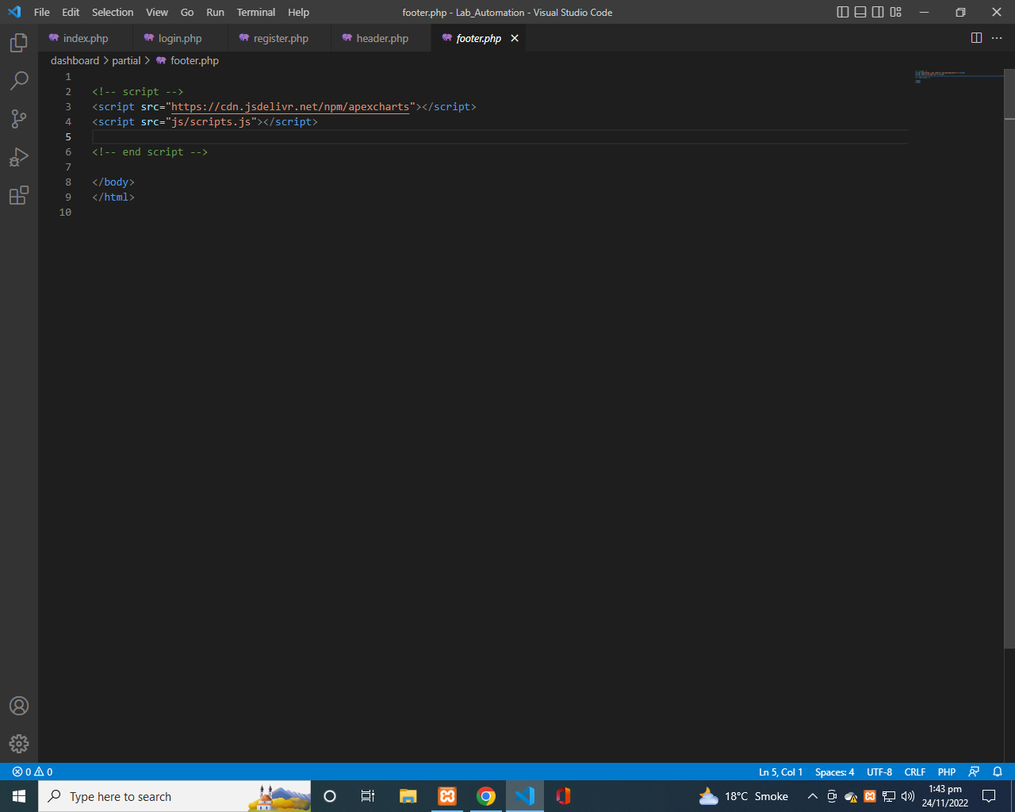

S.S 8: dashboard welcome code

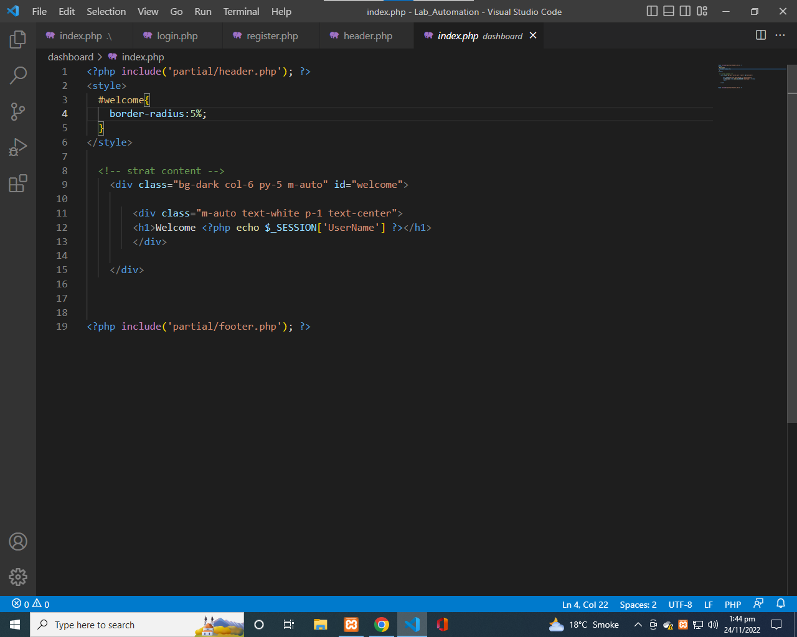

S.S 9: dashboard logout code

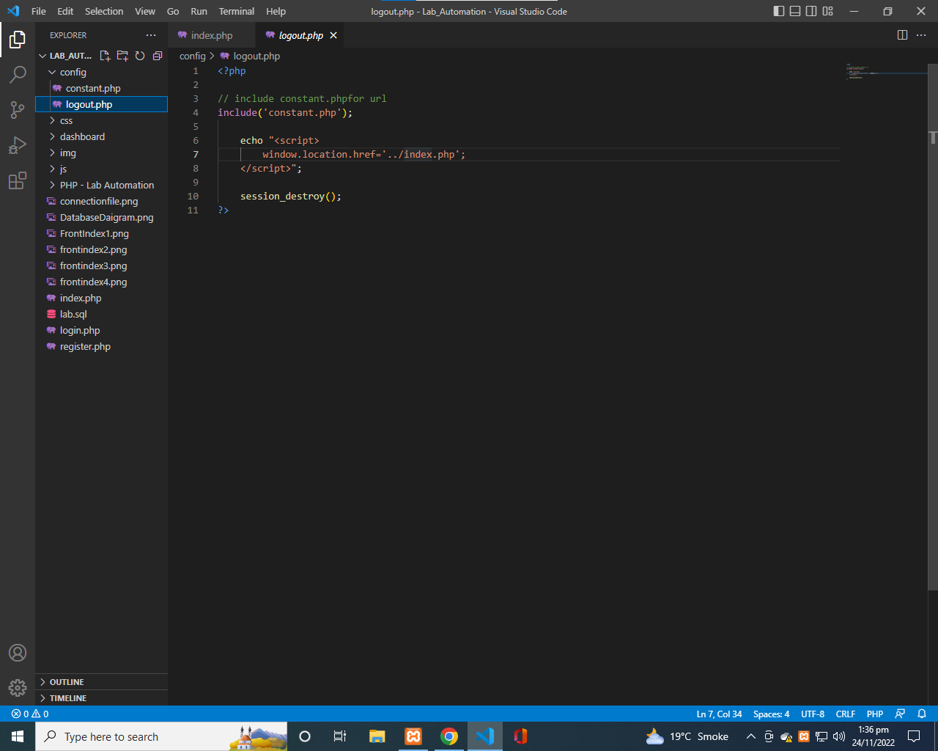

*TASK SHEET*

|  |  |
| --- | --- |
| *Enrollment No.* | *Students Name* |
| Student 1307673 | **Abdullah Khan** |

|  |  |
| --- | --- |
| *Member Name:* | *Task Done:* |
| 1: Abdullah Khan | Analyzing, Problem Solving,  Coding, Logics, Scenarios,  Analyzing, Graphic user Interface (GUI), User guide  Documentation. |

FINAL CHECK LIST

|  |  |  |
| --- | --- | --- |
| *Particular’s* | *Checked* | *Unchecked* |
| Database (on SQL) |  |  |
| Entity relationship diagram (E-R diagram) | * Null |  |
| Admin & Client Dashboard |  |  |
| Reliability |  |  |
| Authentications |  |  |
| Documentation |  |  |

***THANK YOU!***